Q1:

#include<stdio.h>

int main(){

int age, cit;

printf("Enter your age:");

scanf("%d", &age);

printf("Enter 1 of you have citizenship and 0 if not:");

scanf("%d", &cit);

if (age >= 18){

if (cit == 1){

printf("Eligible to Vote!");

} else{

printf("Not Eligible to Vote!");

}

} else{

printf("Not Eligible to Vote!");

}

return 0;

}

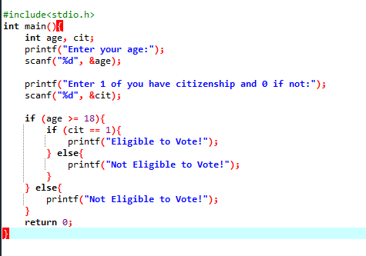

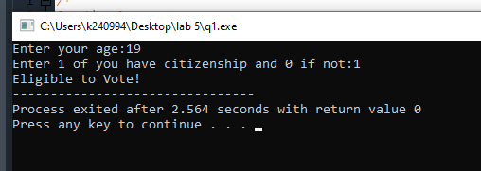

Q2:

#include<stdio.h>

int main(){

int a1, a2, a3;

printf("Enter the First Angle: ");

scanf("%d", &a1);

printf("Enter the Second Angle: ");

scanf("%d", &a2);

printf("Enter the Third Angle: ");

scanf("%d", &a3);

if (a1 >=0 && a3 >=0 && a2 >=0 ){

if (a1 + a2 + a3 == 180){

printf("Triangle is Valid");

} else{

printf("Triangle is inValid");

}

} else{

printf("Angle is invalid as it is negative");

}

return 0;

}

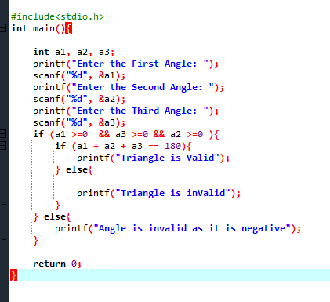

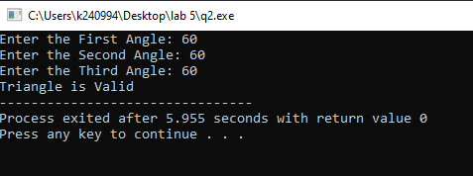

Q3:

#include<stdio.h>

int main(){

int percentage;

printf("Enter the percentage: ");

scanf("%d", &percentage);

(percentage >= 90) ? printf("A") : (percentage >= 80 && percentage < 90) ? printf("B"): (percentage >= 70 && percentage < 80) ? printf("C"): (percentage >= 60 && percentage < 70) ? printf("D"): printf("F");

return 0;

}



